Circular Level Tool

There is a critical interface between the objective and the stage. Anytime this interface is disrupted, either by rough service or from a unit that has been repaired, this interface must be restored in order to maintain the optical path alignment both below and above the objective. The stage and optical center (objective mount) MUST be perpendicular to each other before any alignment can be accomplished. Any misalignment from true can show up as a side to side (or front to back) movement in the image focus and as an illumination shift. Without this alignment being perfect, you'll be "beating a dead horse" farther along the scope. There is a special tool available to ensure this alignment between the stage and objective. Some call it a "mushroom tool." A colleague of mine, here in Colorado affectionately calls it a "circular level." It's basically a tool with an objective (RMS) thread that screws into the objective mount that then gives a reference of that plane down to the stage. You then level the stage to the tool. Many microscopes also have the condenser rack and pinion slide mount attached to the focus block. Reestablishing the stage and focus block will usually address condenser problems that might show up as an image and/or illumination shift. This tool is precision machined using brass and aluminum and is supplied with a keeper (as shown) to protect the RMS microscope thread. The Circular Level Tool is available for $76.00 and USPS Priority (US) shipping at $5.05.

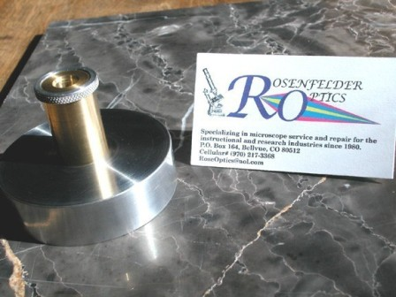

This is the tool I use in the field. In my shop I use an auto-collimator. Using the top mount, where the mono or binocular head mount as reference, and as a place to set the collimator, I can then shoot a collimated "beam" with the crosshair image all the way down the scope. Using a first surface mirror, and by placing this mirror either on the stage, condenser mount or field mount, the crosshair image reflects back up the system and I can measure the amount of deviancy from perpendicular and make the proper adjustments. I'm not trying to teach everyone how to align their microscopes, but for those of you who will try anyway, chasing this non perpendicular problem is one of the biggest errors to be made.

